Bannari Amman Institute of Technology

Sathyamangalam -638 401,Erode District ,Tamil Nadu

DEPARTMENT OF COMPUTER SCIENCE AND ENGINEERING.

WEB PHISHING DETECTION

(**ASSIGNMENT 1)**

DATE : 20-09-2022

PROBLEM : TO ANSWER THE QUESTIONS FOR THE ANSWERS

NAME: SABARISSHAN G K

OUTPUT : SCREENSHOTS:

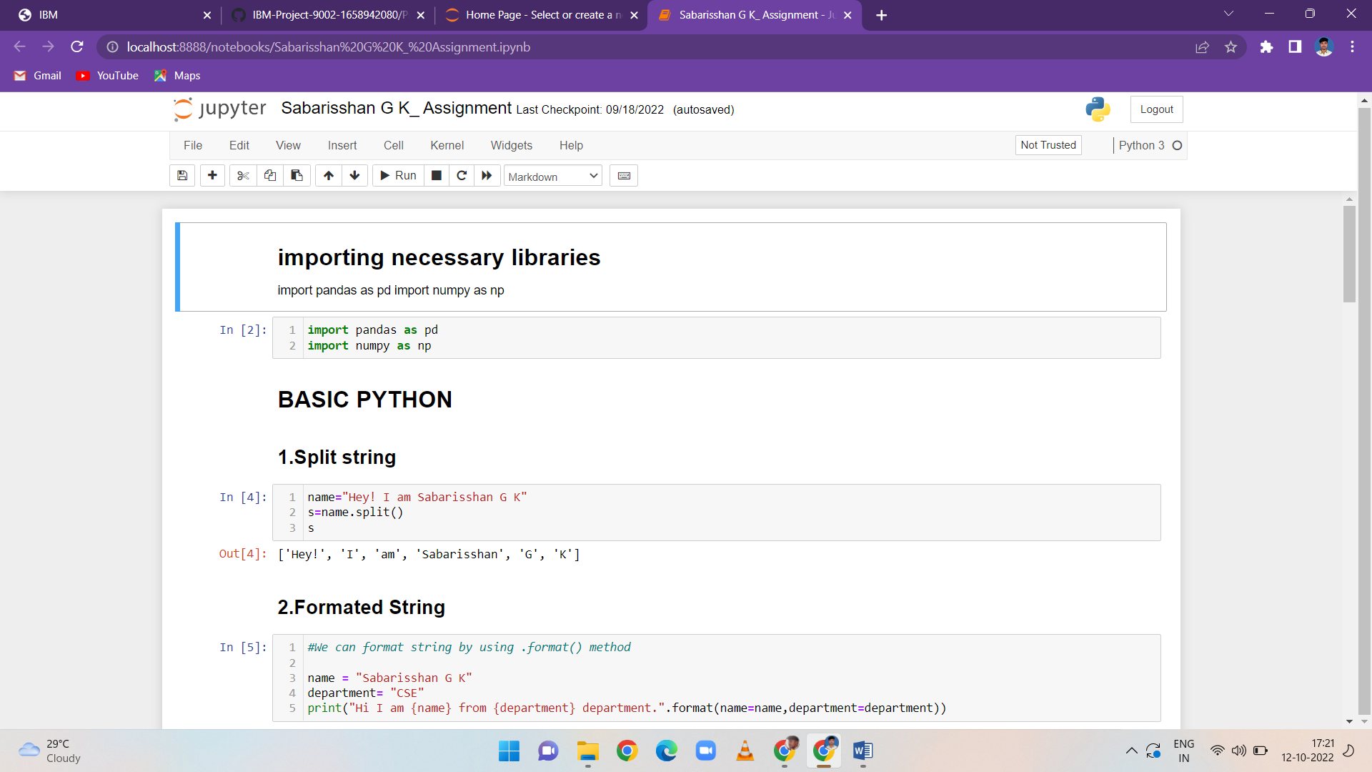

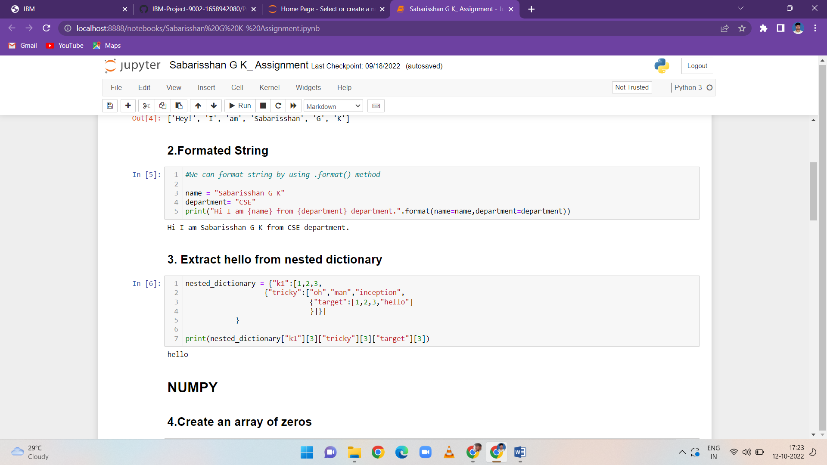

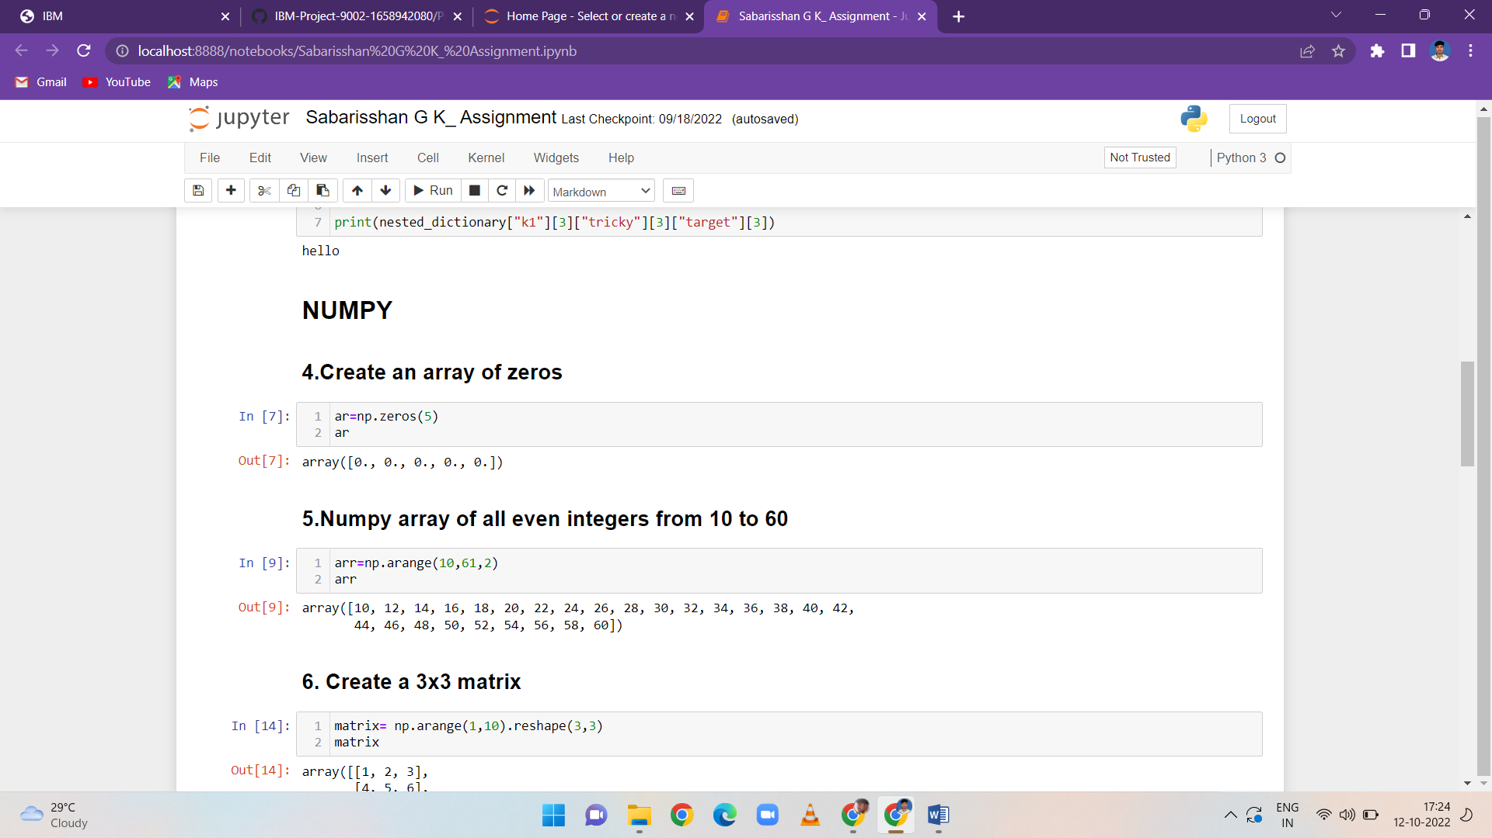

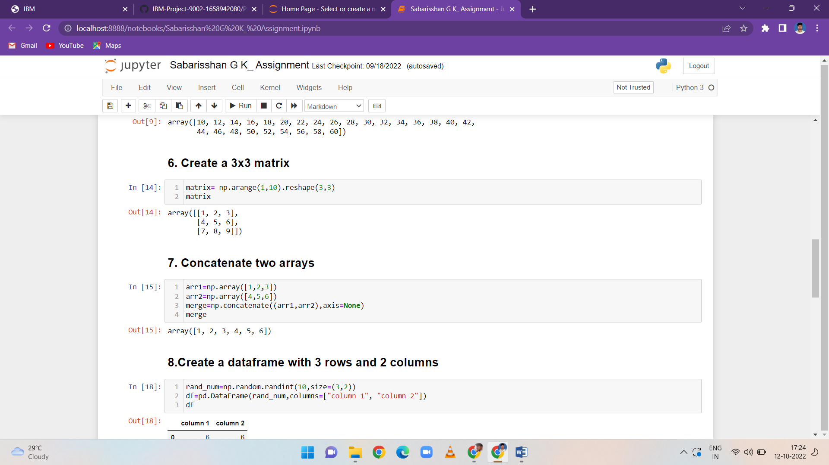

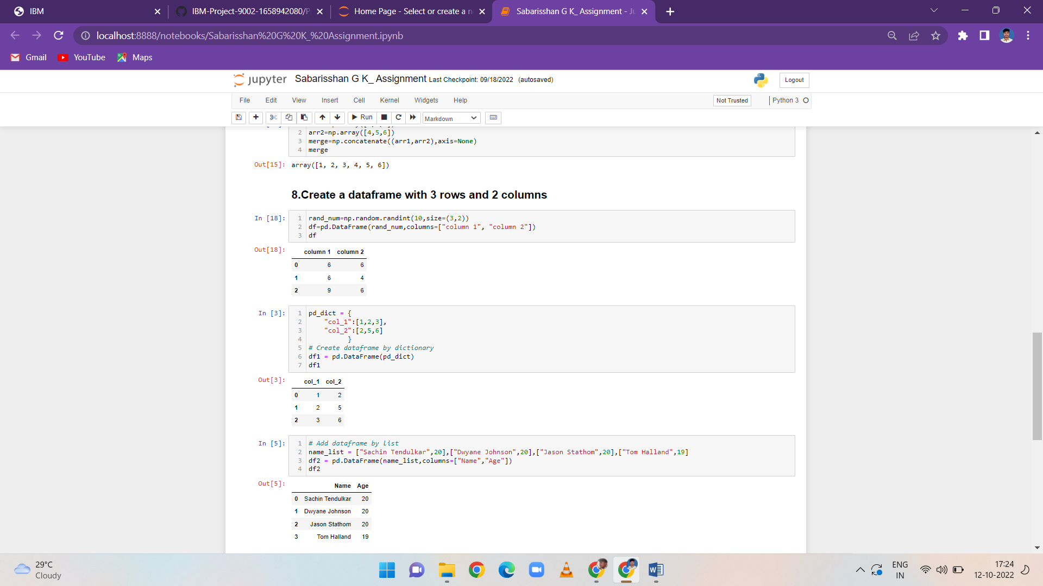

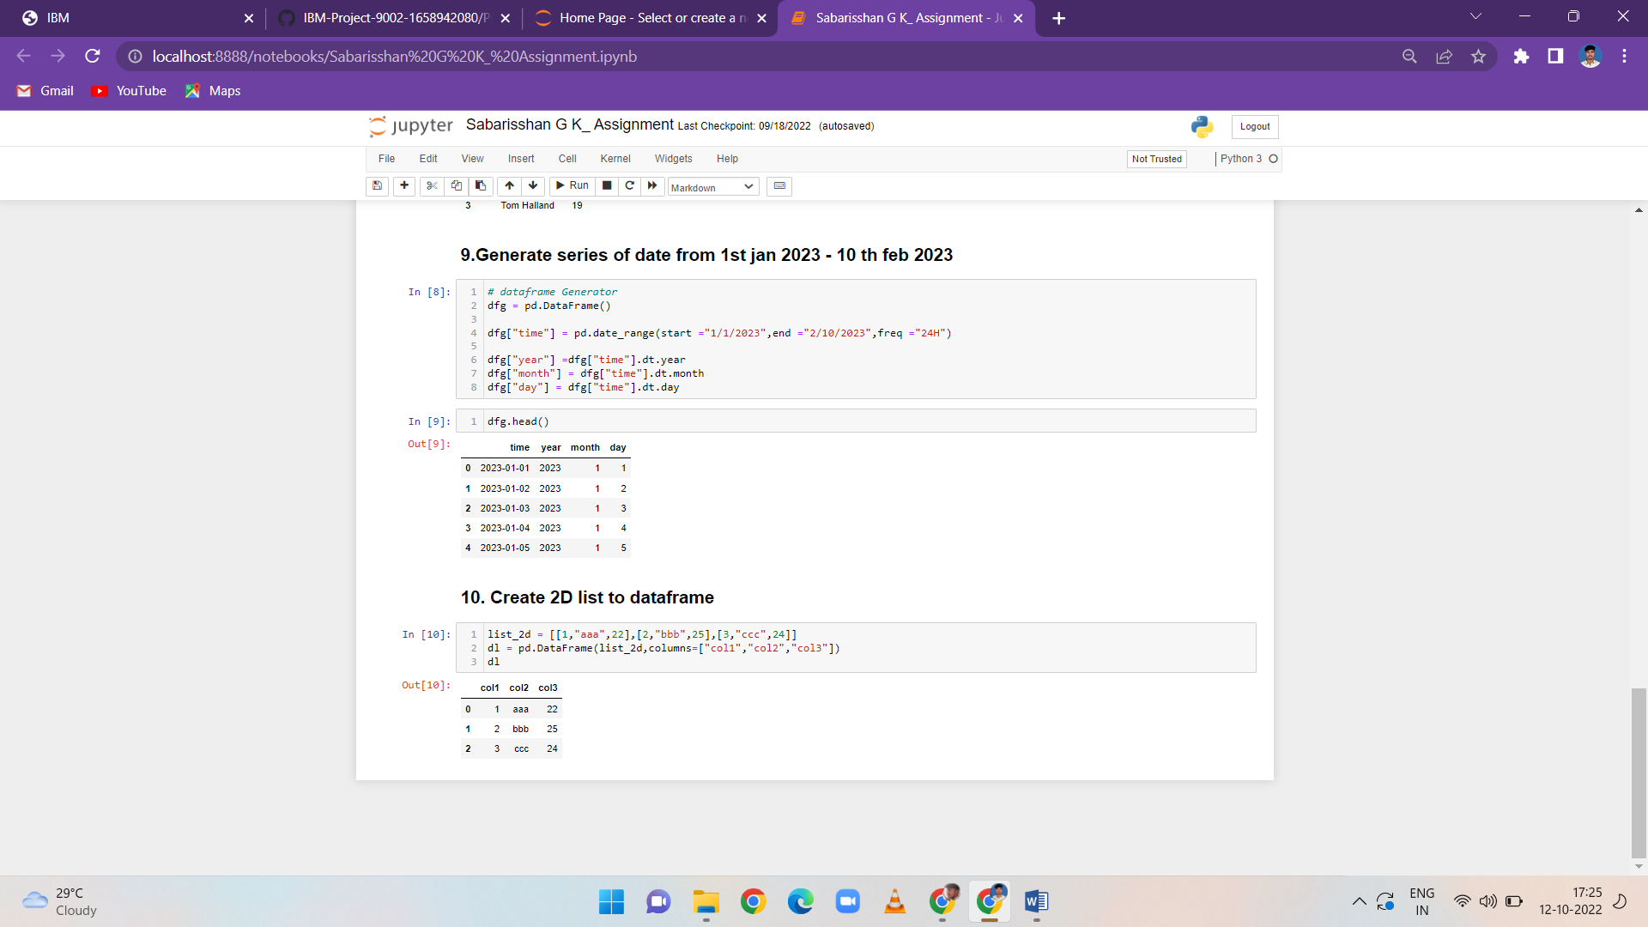

*****************************THANKING YOU***********************************